eProject: Pascal Imitation Jewellery

PASCAL IMITATION JEWELLERY

|  |  |  |
| --- | --- | --- |
| **Supervisor.** | HASNAIN ALI | |
| **Batch.** | 2407G2 | |
| **Group.** | C | |
| **Serial No.** | **Enrollment Number** | **Student Name** |
| 1. | Student1597584 | ARZAM NAVAID |
| 2. | Student1597219 | M.ABDULLAH |
| 3. | Student1597526 | M.HASSAAN RAZA |
| 4. | Student1596608 | TAHA FAISAL MANSOOR |
| 5. | Student1597219 | M.ZAIN KHAN |
|  |  |  |

eProject: Pascal Imitation Jewellery

# ACKNOWLEDGEMENT

The first, we would like to express my special thanks of gratitude to my teacher Hasnain Ali, who helped us a lot in finalizing this project within the limited time frame, valuable counselling and assistance for the accomplishment of this project.

Secondly, we would also like to thank the eProject team at Aptech Head Office, who gave us the golden opportunity to do this wonderful project about Aura Watch.

Thirdly, we also thank the eProject team, some of the benefits are as under:

* **Re-enforcement of Skills**: eProjects provide an opportunity for experiential learning, allowing you to actively apply the knowledge and skills you've gained. This reinforces learning by giving you a hands-on approach to problem-solving and project execution.
* **Guidance from a Mentor**: Throughout the project, a mentor ensures that you stay on track and do not veer off course. The mentor provides valuable feedback, suggestions, and insights, helping you overcome obstacles and achieve your project goals effectively.
* **Boosts Confidence for Interviews**: Working on an eProject boosts your confidence in job interviews. With practical experience, you can speak confidently about the work you’ve done, explaining the challenges you faced, the solutions you implemented, and the knowledge you acquired, which demonstrates your competence to potential employers.
* **Enhanced Credentials**: Completing an eProject often culminates in a final, polished report—typically bound in a professional black hardbound format. This report acts as a testament to your hard work and can significantly enhance your resume, improving your job prospects by showcasing your commitment, skills, and project management abilities.

eProject: Pascal Imitation Jewellery

# SYNOPSIS

The rapid pace of technological advancements in the IT industry requires professionals to continuously learn and apply new concepts. However, busy work schedules and the challenge of finding suitable time-slots hinder the application of knowledge in real-life scenarios. This issue is also a challenge for students in the field of IT education, where technology evolves quickly. To address this, Aptech aims to revolutionize the learning experience by offering a live, synchronous eProject learning environment. This approach allows students to engage with tools directly, learn at their own pace, and apply concepts in real-time, leveraging technology to enhance their education and skill development.

2

# PROBLEM DEFINITION

The task is to develop a user-friendly and informative website for *PASCAL IMITATION JEWELLERY*. The website should include sections to describe the different types of jewelry products, categorize them by brand and type, provide detailed product descriptions with images, and allow customers to compare products. It must also feature sections for contact, about us, feedback, and a gallery. The website should have a smooth and consistent design with easy navigation. So, we solved many particular queries as followed:

1. Create a homepage with highlights and navigation links.
2. Organize products by brand and sub-categories (Original, Semi-Precious, Artificial).
3. Add detailed product descriptions and images.
4. Implement a product comparison feature.
5. Include sections like "Contact Us," "About Us," "Feedback Form," and "Gallery."
6. Ensure a uniform color scheme and smooth navigation across the site.

1

# CUSTOMER REQUIREMENT SPECIFICATION (CRS)

The website will serve as an online platform for showcasing and selling imitation jewelry, aiming to provide a seamless shopping experience while enhancing customer engagement.

**2. Functional Requirements:**

* **Product Display & Categorization:** Display products by category (e.g., rings, necklaces, earrings) and type (e.g., semi-precious, artificial, original), with detailed descriptions, images, and pricing.
* **Product Comparison:** Allow customers to compare products based on design, material, price, and features.
* **Shopping Cart & Checkout:** Enable users to add items to the cart and complete secure, multi-step checkouts with various payment options.
* **Customer Account Management:** Allow customers to create accounts, track orders, and recover passwords.
* **Customer Support:** Include contact forms, FAQs, and live chat options.
* **About Us & Gallery:** Feature the company’s mission and a gallery showcasing jewelry collections.
* **Reviews & Feedback:** Enable product reviews and general feedback forms for customers.
* **SEO & Marketing:** Implement SEO, Google Analytics, and email subscription for promotions.

**3. Non-Functional Requirements:**

* **Usability:** Easy navigation and visually appealing design.
* **Performance:** Fast loading times and responsive design for all devices.
* **Security:** SSL encryption for secure transactions and data protection.
* **Accessibility:** Website must meet accessibility standards.
* **Maintenance:** Easy updates for products and content.

**4. Design & Aesthetic Requirements:** The design should reflect luxury and elegance, consistent with the brand's identity.

**5. Technical Requirements:** The website should be built on a scalable platform (e.g., WordPress, Shopify) and integrate with secure payment gateways and social media.

**6. Constraints:** The website must meet budget, timeline, and legal compliance requirements, ensuring compatibility across browsers.

# SCOPE OF THE WORK (IN BRIEF)

The *Imitation Jewellery* website will be developed to showcase and sell jewelry products online, offering a seamless user experience. Key components of the website include:

1. **Product Display and Categorization:** Products will be organized by categories (e.g., earrings, necklaces) and types (e.g., semi-precious, artificial). Each product will have detailed descriptions, images, and pricing.
2. **Product Comparison:** A feature to compare different products based on attributes such as material, design, and price.
3. **Shopping Cart and Secure Checkout:** A simple, secure checkout process with multiple payment options, along with an easy-to-use shopping cart for customers to review their selections.
4. **Customer Account Management:** Users can create accounts to track orders, manage personal details, and view order history.
5. **Contact and Support:** A contact form, location details, and customer support options will be provided for inquiries.
6. **About Us and Gallery:** A section detailing the company’s mission and values, along with a gallery showcasing different jewelry collections.
7. **Feedback and Reviews:** Customers can leave reviews for products and provide feedback on their experience.
8. **SEO and Digital Marketing:** Optimized content for search engines, integration of Google Analytics, and options for email marketing.
9. **Security and Maintenance:** The website will be secure, with SSL encryption and ongoing maintenance to ensure smooth performance.

# AGGREGATED SITEMAP

Imitation Jewellery

(0.Welcome.html)

Pascal Imitation Jewellery  
(1.Index.html)

eproject: Pascal Imitation Jewellery

# SITEMAP ENGLISH



Checkout  
  
 (2.checkout.html)

Checkout

Checkout.html

Precious 

CheckOut (Checkout.html)

Artificial products

(2. Artificial products.html)

Semi precious Products  
  
 (2. Semi precious Products.html)

Precious Products (2. Precious Products html)

**Checkout**

(6.Checkout.html)

**About Us**

(5.Aboutus.html)

Silver Tone Watch (Products-W-4.html)

Aura Stardust Watch (Products-W-3.html)

Butterfly Dial Watch (Products-W-2.html)

Pascal Imitation Jewellery  
(1.Index.html)

**Home Page**

(1.Index.html)

**Products Page**

(2.Products.html)

**Gallery**

(3.gallery.html**)**

**Contact Us**

(4.contactus.html)

7

1

eProject: Pascal Imitation Jewellery

# WIREFRAMES

1. Home Page (1.Index.html)

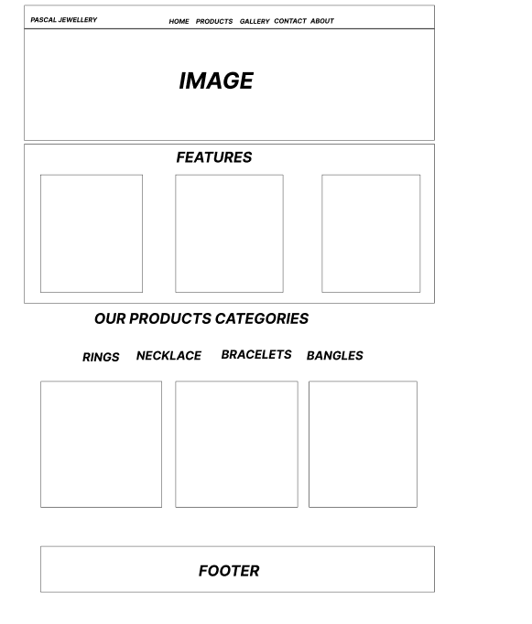

3

eProject: Pascal Imitation Jewellery

4

eProject: Pascal Imitation Jewellery

5

eProject: Pascal Imitation Jewellery

1. Product Page (2.Products.html)

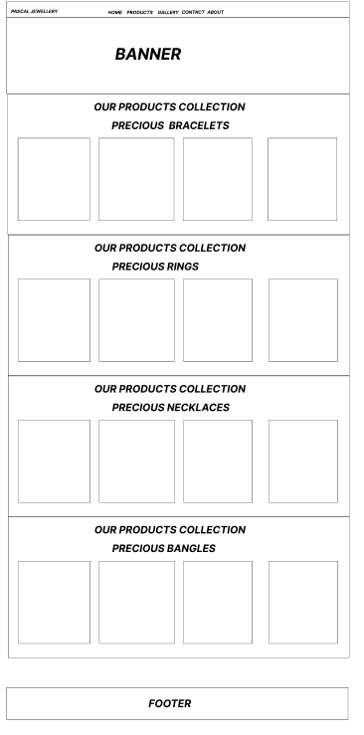

6

eProject: Pascal Imitation Jewellery

3

eProject: Pascal Imitation Jewellery

4

eProject: Pascal Imitation Jewellery

5

eProject: Pascal Imitation Jewellery

7

eProject: Pascal Imitation Jewellery

8

eProject: Pascal Imitation Jewellery

10

11

12

eProject: Pascal Imitation Jewellery

# TASK SHEET REVIEW 2

|  |  |  |  |  |  |  |
| --- | --- | --- | --- | --- | --- | --- |
| Project Ref. No.: eP/Advertisement Portal Management  System/01 | | Project title | Date of Preparation of Activity Plan | | | |
| No | Task | Pascal Jewellery | Actual | Actual | Team-mate | Status |
| Start Date | Days | Names |
| 1 | Build Home | 5/12/2024 | 1 | Arzam | Complete |
| Page |
| 2 | Build Product precious product page | 6/12/2024 till 7/12/2024 | 2 | M.Abdullah | Complete |
| 3 | Build Product semi-precious product page | 8/12/2024 till 10/12/2024 | 2 | M.Abdullah | Complete |
|  |
|  |
| 4 | Build Artificial Product page | 11/12/2024 till 14/12/2024 | 3 | M.Abdullah | Complete |
| 5 | Begin Code  Javascript For The Home Page | 15/12/2024 till 18/12/2024 | 3 | M.Abdullah | Complete |
| 6 | Begin Code | 19/12/2024 till 22/12/2024 | 4 | M.Abdullah | Complete |
| Javascript For The Product  Pages |
|  |
| 7 |  | 23/12/2024 | 1 | Arzam | Complete |
| Build Gallery page |
|  |

13

|  |  |  |  |  |  |  |
| --- | --- | --- | --- | --- | --- | --- |
| 8 | About us |  | 24/12/2024 | 1 | Arzam | Complete |
| 9 | Contact us | 25/12/2024 | 1 | Arzam | Complete |

eProject: Pascal Imitation Jewellery

# TASK SHEET REVIEW 3

|  |  |  |  |  |  |  |
| --- | --- | --- | --- | --- | --- | --- |
| Project Ref. No.: eP/Advertisement Portal Management  System/01 | | Project title | Date of Preparation of Activity Plan | | | |
| No | Task | Pascal Jewellery | Actual Start Date | Actual Days | Team-mate Names | Status |
| 1 | Check color format, size, javascript, responsive in the Home page | 26/12/2024 | 1 | Arzam | Complete |
| 2 | Check color format, size, javascript, responsive in Product page and Product pages | 26/12/2024 | 2 | M.Abdullah | Complete |
| 3 | Write a developer guide | 27/12/2024 | 2 | M.Abdullah  Arzam | Complete |
| 5 | Write user manuals |
| 6 | Overall inspection of the project | 28/12/2024 | 2 | M.Abdullah  Arzam | Complete |

15

14

eProject: Pascal Imitation Jewellery